**Time Management**

Time

Time is defined as the duration in which all things happen, or a precise instant that something happens. An example of time is the Renaissance era. An example of time is breakfast at eight o'clock in the morning. An example of time is a date at noon next Saturday.

Time Management

“Time management” is the process of organizing and planning how to divide your time between specific activities. Good time management requires an important shift in focus from activities to results being busy isn't the same as being effective.

Time Management is important because:

• Time is both a limited and essential commodity

• It directly impacts productivity

• By managing one’s time, tasks can be completed within deadlines

• Reduces stress

Time management is essential to:

• keep a track of various tasks

• avoid spending time on only one task

• vital factor for productivity

• poor time management impacts all areas of life

Effective Time Management

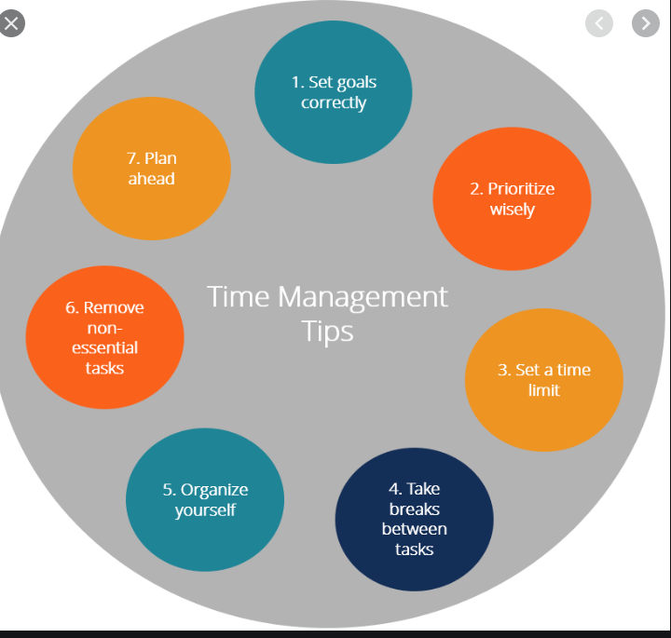

Symptoms of Poor Time Management

• Poor punctuality

• Rushing through things

• Impatience

• Procrastination

• Overflowing inbox

• Poor performance

• Lack of energy, etc.

Effective Time Management for Students

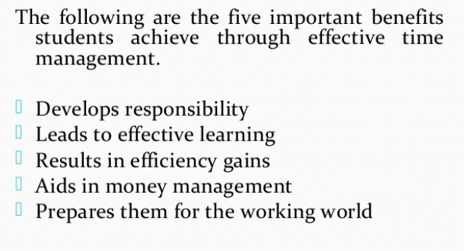

Tools and Techniques of Time Management

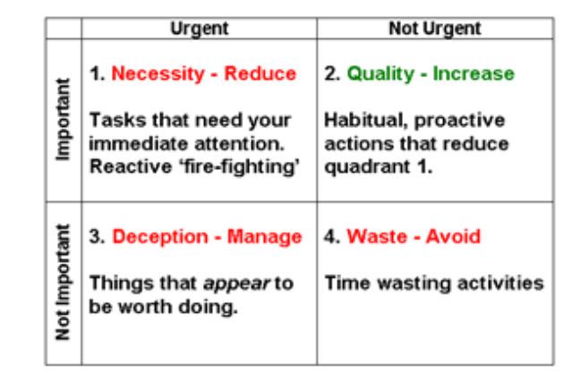

Time management matrix

Quadrant 1 - Urgent and Important

The Quadrant of Necessities - reactive tasks that need to be done, often at the last minute. Crises, 'fire-fighting' and looming deadlines are typical examples. Time spent in this quadrant cannot be avoided, but it can be significantly reduced if you're prepared to spend more time in

Quadrant 2 - Important but not Urgent

The Quadrant of Quality - proactive tasks, often habitual, that maintain or improve the quality of your work and life. This is the one to aim to spend more time in.The more you expand this quadrant, the more you reduce the other three, particularly 'pseudo-emergencies' that should never have been allowed to become so.

Quadrant 3 - Urgent but not Important

The Quadrant of Deception - plenty of people have gone home in the evening wondering where all the time went. Well, it was here! It's so easy to get sucked into doing things that are the wrong side of the 80-20 rule.

Quadrant 4 - Neither Urgent or Important

The Quadrant of Waste - you know what it is, and you know when you have been in it. The trick is to know when you are in it. Often, it starts out as restful time (which is Quadrant 2). The tipping point comes when you spend too long doing mindless things.

Time Management Tips

• Use a daily planner

• Keep your planner with you all the time

• Set goals

• Group similar tasks

• Set apart time to access your phone/social media

• Avoid multi-tasking

• Create time blocks for studies and other activities, etc.

Benefits of Time Management

• Complete assignments on time

•Improved health and happiness

•Less wasted time:

•More time for other interests/activities

•Flexibility

•Career enhancer, etc.

Summary

-Time Management is the way one organizes and allocates time for

various activities.

-Time Management is important for many personal and professional reasons.

-Parkinson’s Law states that work expands to fill the time available for its

completion.

-There are three important aspects of student life - academics, social life, and self.

-Quadrant II of the time management matrix is the heart of effective personal

management.

-Eating the frog is doing the biggest and most unpleasant task of the day first